Introduction:

This is a demonstration of a Scenix SX microcontroller performing frequency detection on an analog signal. The user selects a frequency, and the SX determines the amount of the selected frequency present in the input signal. The magnitude of the signal is then output to the terminal in a "level-meter" display. Several Virtual Peripherals are utilized for this application:

- Sigma-Delta Analog to Digital converter

- Modified First-Order Goertzel Algorithm

- 115.2k UART

The Detection Algorithm

In this interpretation of the Goertzel Algorithm, we utilize a 1-bit Sigma-Delta Analog to Digital converter. Most DSP algorithms require the processor to store hundreds of values and post-process them. Since this Scenix algorithm processes the incoming signal as it is sampled, RAM usage is tiny and the processing required after a sampling period is minimized. Also, because the analog to digital conversion is only a 1-bit conversion, only an add- or subtract-function is executed on each sample. Over a period of time, the result is the same as multiplying a multi-bit sample by a coefficient and accumulating the results, but the multiplication process is eliminated. Though each sample is of 1-bit resolution, the overall resolution is good because the input signal is oversampled. (400x oversampling on a 1kHz input signal.)
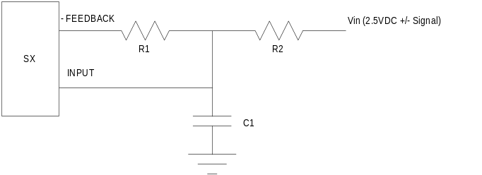

The hardware required to perform frequency detection on an SX consists of only two I/O pins of the SX, 2 resistors, and a capacitor.

A sine and a cosine reference wave are generated at the frequency to be detected. Each 1-bit A/D sample determines whether or not to add or subtract the value of each reference wave from its respective sine accumulator or cosine accumulator,

After a period of time has passed (20ms), the value stored in these accumulators indicates the amount of the detected frequency present in the signal. To determine the amount of the selected frequency detected in the signal, this calculation is used:

Frequency Magnitude = (accumulated sine result² + accumulated cosine result²) ⁻²

The result of this calculation is normalized and output to the terminal screen in a "level-meter" format.

Some possible applications of this algorithm are:

- Spectrum Analysis

- DTMF (Dual-Tone Multiple Frequency) detection

- Call-Progress detection

